Streamlined shark skin replicated by 3d printers
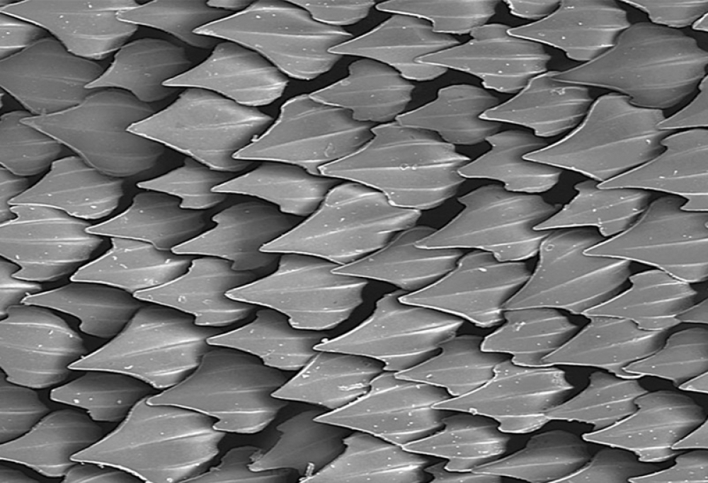
The shark is undoubtedly is the king of the sea, they are known for their amazing speed and agility to move through the water. Sharks skin is rigid and tough and has long baffled scientists as to just how sharks can move so rapidly and effortlessly through the water.
Researchers and engineers have successfully replicated an artificial shark skin by using a 3d printer and embracing 3d printing technology. Swimmers who have put on swimming suits which have been made from the artificial shark skin materials have seen an increase in swimming speed, an amazing increase of up to 6.6%.
Having had the opportunity to touch and feel shark skin personally, it looks smooth almost velvet like but feels grainy and bumpy. Shark skin is in fact made up from millions of little minute ragged scales called denticles. As the shark swims the tiny scales work in making it more streamlined when progressing through the water and reduce the drag effect the water has on the shark.
After successfully creating an artificial but life like shark skin, scientists have been able to test its durability and it’s also how it could be used by humans in a number of different ways. The initial creation of the shark skin proved a little difficult, using a 3d printer the team embedded the tiny denticles tooth like scales onto a suitable flexible membrane.
The exploration of shark skin has only been made possible by the advanced forms of 3d printing that are around today. It’s with the help of 3d printing that the positive elements of shark skin can be explored and studied in ways to see how its amazing abilities can be embraced and used by mankind.
If shark skin can be fully replicated to a high standard of artificial materials then it could be revolutionary in improving swimming clothes and materials and also could make our nautical fleets more efficient in travelling through the seas.

